Donate to help others AND help your school!

Barley Sheaf School

CLOTHING DRIVE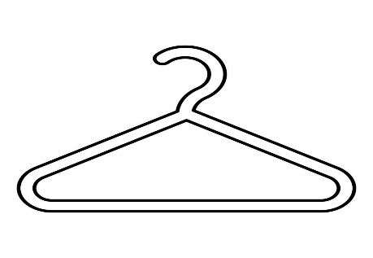

Collection times are:

**May 16th from 4-7 pm &**

**May 17thth from 9am-10:30am**

Donate the following clean items:

* Usable Clothing
* Stuffed Animals
* Handbags & Shoes
* Hats, Belts, Scarves, Gloves
* Bikes & Strollers
* Bedsheets, Towels, Tablecloths

NO LONGER ACCEPTING CAR SEATS OR LARGE TOYS

Please bring all your donations to the front of Barley Sheaf School in **tied plastic bags.**

Tax receipts will be available for your charitable donation.

For more information on where your used items are going, visit – aeclothing.net.

**Thanks for your support of our great school!**

Please contact Jessica Ur with any questions: jessicag002@gmail.com